Visual Literacy, Critical Thinking and Academic Conversations

Any of the powerpoints created on the Conclave can be used to foster visual literacy, critical literacy, religious literacy and the skills needed for academic conversations.

Visual literacy is the ability to understand and interpret the representation and symbolism of static or moving visual images (i.e., the ways in which images are organized and constructed to make meaning) and to understand the impact of images on viewers. (http://www.catholiceducation.org/articles/lesson_plans/lp0008.html)

Critical literacy is a process of looking beyond the literal meaning of texts to observe what is present and what is missing, and thereby to analyse and evaluate the meaning and the author’s intent. Critical literacy goes beyond conventional critical thinking because it focuses on issues related to fairness, equity, and social justice. Students take a critical attitude by asking what view of the world the text advances and whether they find this view acceptable.

(http://www.catholiceducation.org/articles/lesson_plans/lp0008.html)

Religious Literacy is the language of Religious Education. It is the literacy needed to understand Sacred Scripture, the main tenets of the faith, moral teaching of the Church, liturgy and prayer, the principles of social justice, the nature of life in community and of the Church’s mission in the world. It refers to a specialized vocabulary and uses theological language accurately and precisely. It enables students to effectively distinguish and use both primary and secondary sources, Religious literacy allows for overcoming cultural and religious intolerance for it recognizes the need to extend to faith traditions outside of Christianity. (Ontario Catholic Elementary Curriculum Policy Document for Religious Education, 2012, pp.49-50)

The diagram below to identifies the 5 core skills of academic conversations.

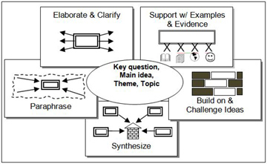

*From: Academic Conversations: Classroom Talk that Fosters Critical Thinking across Disciplines*

(September 2011, Stenhouse Publishing)

PowerPoint presentations are located on Docushare. The toggles needed are:

DocuShare>FaithFormation>ConclaveLessons&Resources: <https://docushare.ncdsb.com/dsweb/View/Collection-382146/Document-1325908>

|  |  |
| --- | --- |
| Powerpoint Title | Recommended Audience |
| Electing a New Pope | Junior, Intermediate, Senior, Adult |
| Conclave 2013 | Primary, Junior |
| Contenders | Intermediate, Senior, Adults |